
COLLEGE of INFORMATION and COMPUTING SCIENCES

ONLINE SHOPPING MANAGEMENT SYSTEM
Software Requirement Specification
Information Technology Project 2025

Submitted by:
Neil Joshua G. Mellejor
Romelyn S. Agoto
Alonna T. Macutay
Diana T. Limon
Elyzabeth M. Mape

Submitted to:
Sir Albert A. Canlas

Table of Contents

Table of Contents 2
1. Introduction 3
1.1 Purpose 3
1.2 Scope 3
1.3 Definitions, Acronyms and Abbreviations 3
1.4 References 4
1.5 Overview 4
2. Functional Data Description 4
2.1 Data Overview 4
2.2 Data Structures 4
2.3 Data Flow 4
2.4 Data Storage 4
3. Subsystem Description 5
3.1 Subsystem Overview 5
3.2 Subsystem 1: [Subsystem Name] 5
3.3 Subsystem 2: [Subsystem Name] 5
3.4 Subsystem N: [Subsystem Name] 5
4. System Modeling and Simulation Results 6
4.1 System Model 6
4.2 Simulation Results 6
5. Products 7
5.1 Product Overview 7
5.2 Product 1: [Product Name] 7
5.3 Product 2: [Product Name] 7
5.4 Product N: [Product Name] 7
6. Appendices 8
6.1 Appendix A: Glossary 8
6.2 Appendix B: References 8
6.3 Appendix C: Change Log 8

1. Introduction
- 1.1 Purpose:
The purpose of this Software Requirements Specification (SRS) document is to provide a detailed description of the requirements for the Online Shopping Management System (OSMS). This system will facilitate online purchasing by providing a platform where users can browse products, place orders, make payments, and track deliveries. It will also enable administrators and vendors to manage product inventories, order processing, and customer data efficiently. The intended audience includes software developers, testers, project managers, and stakeholders involved in the development and deployment of the OSMS.
- 1.2 Scope:
The Online Shopping Management System is a web-based application that serves as a virtual marketplace. The system will support functionalities such as product browsing, searching, user registration and login, shopping cart management, order processing, secure payment integration, and user reviews. Additionally, administrative functionalities will include inventory management, user management, sales reporting, and order tracking. The system aims to enhance the user shopping experience while offering a scalable solution for retailers.
- 1.3 Definitions, Acronyms, and Abbreviations:
OSMS: Online Shopping Management System
SRS: Software Requirements Specification
UI: User Interface DBMS: Database Management System
HTTP: Hypertext Transfer Protocol
SSL: Secure Sockets Layer
- 1.4 References
- IEEE. (1998). IEEE Recommended Practice for Software Requirements Specifications (IEEE Std 830-1998). IEEE.( https://ieeexplore.ieee.org/stamp/stamp.jsp?tp=&arnumber=720574&isnumber=15571)
- Sommerville, I. (2016). Software Engineering (10th ed.). Pearson Education.
- Pressman, R. S., & Maxim, B. R. (2014). Software Engineering: A Practitioner's Approach (8th ed.). McGraw-Hill.
- Laudon, K. C., & Traver, C. G. (2021). E-commerce 2021: Business, Technology and Society (16th ed.). Pearson.
- Overview:
This Software Requirements Specification (SRS) document provides a detailed description of the functional and non-functional requirements for the Online Shopping Management System (OSMS).

The OSMS aims to provide a user-friendly, secure, and scalable e-commerce platform that allows;
Customers/ users:
- Create an account
- Log in
- Browse product
- Add item to shopping cart
- Buy products
- Make payments
- Track orders
- Make reviews
Administrator/Admin/Manager:
- Manage inventory
- View order details
- User management(customer/seller)
- Sales reporting
- Order tracking
- Manage payment method
Seller:
- Create an account
- Log in
- Manage inventory
- Order tracking
- Upload product
- Process payment
- Respond to customer queries

2. Functional Data Description
The Online Shopping Management System (OSMS) outlines the data management that detailing the types of data processed, their structures, flow, and storage methods.
- 2.1 Data Overview
- User data:
Function – manage user accounts and its authentication.
- User reviews:
Function – this manage the user feedbacks.
- Product data:
Function – manage the information of a product list.
- Product category:
Function – this is where the product is organized and is structured in a category.
- Shopping cart data:
Function – holds the selected product by users/customers for buying.
- Order data:
Function – manages confirmed purchases and track order status.
- Payment data:
Function – records payment information for transaction.
- Shipping data:
Function – tracks shipment delivery information.
- Admin data:
Function – manage system and control user roles and product approval.

- 2.2 Data Structures:
User data:
User profiles:
- User_id(primary key)
- full name
- password
- email
- address
- contact number
- user roles(user, admin)
User reviews:
- review_id(primary key)
- user_id(foreign key)
- product_id(foreign key)
- rating(scale{1-5})
- comment
Product data:
- product_id(primary key)
- category_id(foreign key)
- product name
- product description
- product price(currency)
- stock quantity
- product image_url
Product category:
- Category_id(primary key)
- Product category
- Product category_id(foreign key, nullable)
Shopping cart data:
- Cart_id(primary key)
- User_id (foreign key)
- Product_id(foreign key)
- Quantity
- Price
Order data:
- Order_id(primary key)
- User_id(foreign key)
- Order date
- Total amount
- Payment status
- Delivery status
Payment data:
- Payment_id(primary key)
- Order_id(foreign key)
- Payment method(gcash, cash on delivery, credit card)
- Payment date
- Amount
- Transaction
Admin data:
- Admin_id
- Name
- Email
- Privileges

- 2.3 Data Flow:
User Registration & Login:
Input | user details (name, email, password, etc.)
Process | User account is created or authenticated.
Output | New user record stored in the *User* database or access granted.
Product Browsing:
Input | User searches or browses categories.
Process | System fetches product listings from the *Product* database.
Output | Product details displayed to the user.
Shopping Cart:
Input | User adds or removes products.
Process | Updates *Cart* table with selected items.
Output | Dynamic cart view for the user.
Order Placement:
Input | User confirms purchase
Process | Order details stored in *Order* table. * Cart data is cleared.
Output | Order confirmation and order ID generated.

Payment Processing:
Input | User provides payment method and confirms payment.
Process | Payment gateway validates transaction.
Output | Payment data stored in *Payment* table. * Order status updated.
Shipping & Delivery:
Input | Order is marked ready for shipping.
Process | Courier and tracking data logged in *Shipping* table.
Output | Shipment tracking available to user.
Review & Rating:
Input | User submits review and rating post-delivery.
Process | Review saved in *Review* table.
Output | Reviews displayed on product pages.
Admin Activities:
Input | Admin logs in and manages products, users, and orders.
Process | Admin interface interacts with all core data tables.
Output | Data updated, reports generated, issues resolved.

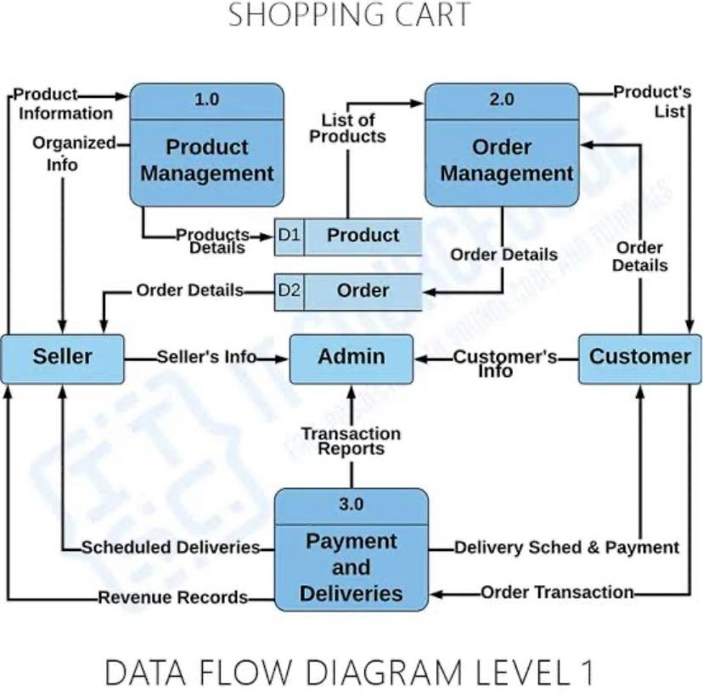

- 2.4 Data Storage:

Users Table:
Users
( user_id INT PRIMARY KEY,
full_name VARCHAR(100),
email VARCHAR(100) UNIQUE,
password_hash VARCHAR(255),
phone_number VARCHAR(15),
address TEXT,
role ENUM('customer', 'admin'),
created_at DATETIME)

Products Table:
Products
( product_id INT PRIMARY KEY,
name VARCHAR(100),
description TEXT,
category VARCHAR(50),
price DECIMAL(10,2),
stock_quantity INT,
image_url TEXT,
created_at DATETIME)

Orders Table:
Orders
(order_id INT PRIMARY KEY,
user_id INT,
order_date DATETIME,
total_amount DECIMAL(10,2),
status ENUM('Pending', 'Processing', 'Shipped', 'Delivered', 'Cancelled'),
shipping_address TEXT,
FOREIGN KEY (user_id) REFERENCES Users(user_id))

Order_Items Table:
Order_Items
( order_item_id INT PRIMARY KEY,
order_id INT,
product_id INT,
quantity INT,
price DECIMAL(10,2),
FOREIGN KEY (order_id) REFERENCES Orders(order_id),
FOREIGN KEY (product_id) REFERENCES Products(product_id))

Payments Table:
Payments
( payment_id INT PRIMARY KEY,
order_id INT,
payment_date DATETIME,
amount DECIMAL(10,2),
payment_method VARCHAR(50),
payment_status ENUM('Successful', 'Failed', 'Refunded'),
FOREIGN KEY (order_id) REFERENCES Orders(order_id))

Reviews Table:
Reviews
( review_id INT PRIMARY KEY,
product_id INT,
user_id INT,
rating INT CHECK (rating BETWEEN 1 AND 5),
comment TEXT,
review_date DATETIME,
FOREIGN KEY (product_id) REFERENCES Products(product_id),
FOREIGN KEY (user_id) REFERENCES Users(user_id))

Cart Table:
Cart
( cart_id INT PRIMARY KEY,
user_id INT,
created_at DATETIME,
FOREIGN KEY (user_id) REFERENCES Users(user_id))

Cart_Items Table:
Cart_Items
(cart_item_id INT PRIMARY KEY,
cart_id INT,
product_id INT,
quantity INT,
FOREIGN KEY (cart_id) REFERENCES Cart(cart_id),
FOREIGN KEY (product_id) REFERENCES Products(product_id))

Shipping Table:
Shipping
( shipping_id INT PRIMARY KEY,
order_id INT,
shipping_provider VARCHAR(100),
tracking_number VARCHAR(100),
shipping_status ENUM('In Transit', 'Delivered', 'Delayed'),
estimated_delivery_date DATE,
FOREIGN KEY (order_id) REFERENCES Orders(order_id))

3. Subsystem Description

- 3.1 Subsystem Overview:
An Online Shopping Management System (OSMS) typically consists of multiple interrelated subsystems that together provide a complete e-commerce experience for both customers and administrators.

- User Management:
This subsystem handles user registration, login, profile management, and potentially, user roles like customer, administrator, or guest. It ensures secure access to the system and manages user-specific data.
- Product Management:
This subsystem focuses on managing the products available for sale. It includes functionalities like adding new products, updating product information (descriptions, prices, images), managing product categories, and potentially, handling product variations (like size or color).
- Order Management:
This subsystem is responsible for processing customer orders. It handles functionalities like adding items to a shopping cart, managing the cart contents, creating new orders, updating order status, and potentially, order fulfillment and shipping.
- Payment Processing:
This subsystem integrates with payment gateways to securely handle online transactions. It manages payment methods, processing payments, and potentially, handling refunds or cancellations.
- Inventory Management (Optional):
Some online shopping systems include an inventory management subsystem to track stock levels of products. This subsystem helps prevent overselling and provides real-time updates on product availability.

- 3.2 Subsystem 1: [web store]:
Handles the user interface and core shopping functionalities. It allows customers to browse products, add items to a cart, manage their accounts, and complete purchases. It also involves features for administrators to manage products, orders, and customer information.

Customer-facing features:
Product Browsing: Customers can search for and view products, often with detailed descriptions, images, and pricing.
Shopping Cart: This allows customers to add and remove items, adjust quantities, and manage the items they intend to purchase.
User Accounts: Customers can register, log in, and manage their profiles, including shipping addresses and payment information.
Checkout Process: This includes selecting a payment method, entering shipping details, and finalizing the purchase.
Order Tracking: Customers can view the status of their orders and track shipments.
Reviews and Ratings: Some systems allow customers to leave reviews and ratings for products.
Communication: Features like messaging and customer support may be included.
Administrator-facing features:
Product Management:
Administrators can add, edit, and remove products, manage categories, and update product information.
Order Management:
Administrators can view, process, and fulfill orders, manage shipping, and handle returns.
User Management:
Administrators can manage customer accounts, including registration, login, and profile information.
Reporting and Analytics:
Systems often provide tools for generating reports on sales, inventory, and customer behavior.
Website Management:
Administrators can manage website content, promotions, and other site-related settings.

- 3.3 Subsystem 2: [ware house]:

Manages the physical storage and movement of goods. It handles inventory, order fulfillment, and shipping processes, ensuring efficient operations and timely deliveries. Key features include inventory tracking, order management, shipping logistics, and potentially returns processing.

- Inventory Management:
Tracking:
Real-time tracking of inventory levels, locations (bays, shelves, etc.), and product details.
Stock Management:
Manages stock quantities, identifies potential stockouts or overstock situations, and facilitates automatic reordering.
Inventory Audits:
Supports regular stock checks and audits to maintain accurate inventory records.
Receiving:
Manages the process of receiving new shipments, including verifying quantities and updating stock levels.

2. Order Management:
Order Processing:
Handles order placement, picking, packing, and shipping.
Picking and Packing:
Provides instructions for picking items from designated locations and packing them for shipment.
Shipping:
Manages shipping logistics, including generating shipping labels, selecting appropriate carriers, and tracking shipments.
Returns:
May include features for processing returns, including receiving returned items, updating inventory, and issuing refunds or replacements.

3. Shipping Logistics:
Carrier Integration: Integrates with various shipping carriers to streamline the shipping process.
Shipping Label Generation: Automates the creation of shipping labels.
Tracking: Provides real-time tracking information for both the warehouse staff and customers.

4. Other Key Functions:
Warehouse Design: May include tools for optimizing warehouse layout and workflows.
Resource Management: Helps allocate labor and manage other resources within the warehouse.
Reporting: Provides reports on inventory levels, order fulfillment, and other key metrics.
Integration: Integrates with other parts of the online shopping system, such as the e-commerce platform and accounting systems..

- 3.4 Subsystem N: [OSMS system]:
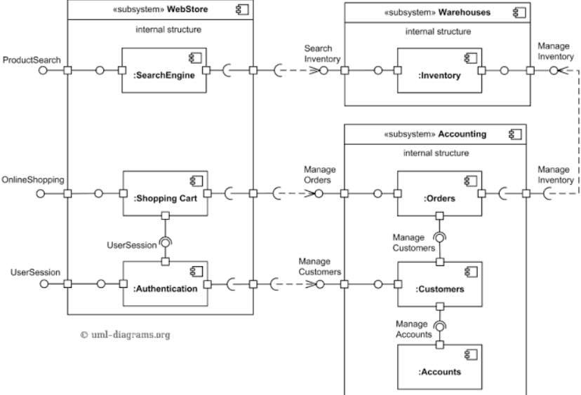

4. System Modeling and Simulation Results
- 4.1 System Model:
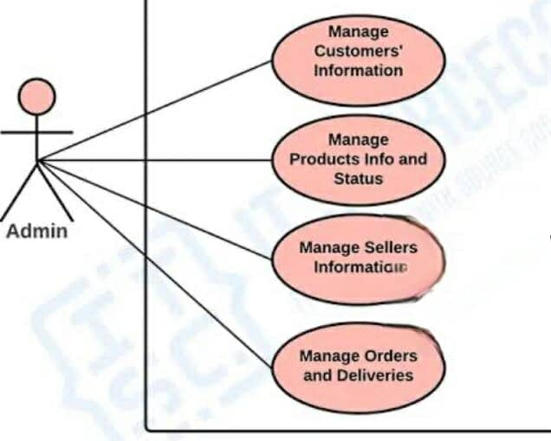

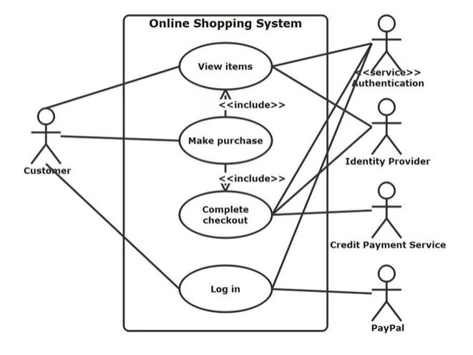
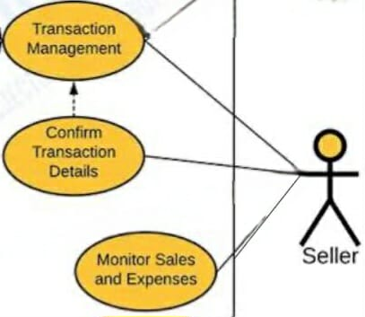
The customer is the end user who purchases products or services, makes payments, and provides feedback. The seller lists and manages products, sets prices, processes orders, and handles inventory.

- 4.2 Simulation Results:
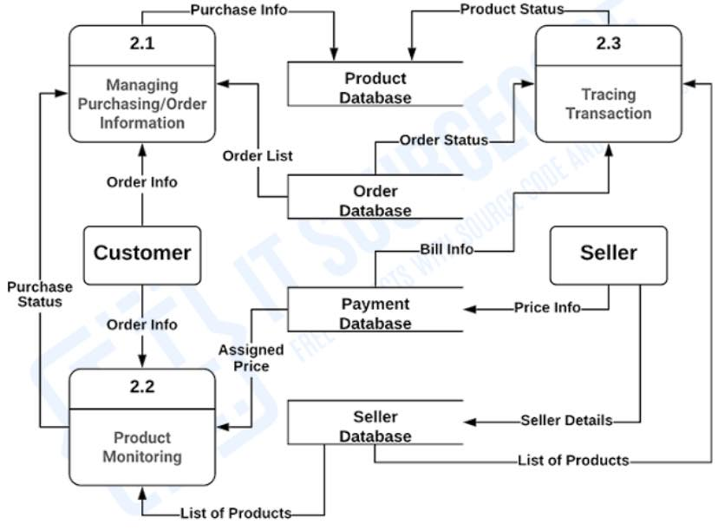

5. Products
- 5.1 Product Overview:
Online shopping management system(OSMS)is a software application that enables businesses to sell products or services over the internet. It provides a platform for customers to browse, select, and purchase items online, while also offering tools for businesses to manage inventory, process orders, and handle payments. These systems are designed to streamline the online sales process, enhancing the customer experience and improving operational efficiency for businesses.

- 5.2 Product 1: [OSMS]:
Product Management:
Allows businesses to add, edit, and categorize products, manage inventory levels, and display product details (descriptions, images, pricing).
Customer Management:
Enables registration, login, and account management for customers, including storing shipping addresses and order history.
Shopping Cart:
Provides a virtual cart where customers can add and remove items before checkout.
Order Management:
Facilitates order placement, processing, and tracking, including payment processing and shipping information.
Payment Processing:
Integrates with various payment gateways to securely handle online transactions.

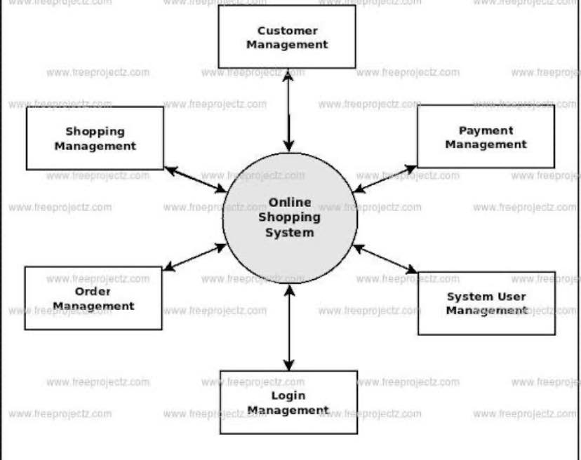

6. Appendices
- 6.1 Appendix A: Glossary:
Admin: A user with elevated privileges who manages the system, including user accounts, products, orders, and overall platform settings.
Cart: A virtual space where users can add products they intend to purchase. It allows users to review their selected items before proceeding to checkout.
Checkout Process: The series of steps a user follows to complete a purchase, including selecting payment methods, entering shipping information, and confirming the order.
Customer: An individual who browses products, makes purchases, and interacts with the online shopping platform.
Data Flow: The movement of data through the system, detailing how input is processed and what output is generated at each stage.
Inventory Management: The process of tracking stock levels, managing product availability, and ensuring that products are replenished as needed.
Order Management: The subsystem responsible for processing customer orders, including order creation, status updates, and fulfillment.
Payment Processing: The handling of financial transactions, including the validation of payment methods and the recording of payment details.
Product Management: The subsystem that manages product listings, including adding, updating, and categorizing products.
Product Category: A classification that organizes products into groups based on shared characteristics, making it easier for users to browse and find items.
Review and Rating: Feedback provided by customers about products, typically including a numerical rating and a written comment.
Shipping Management: The process of preparing orders for delivery, including logistics, tracking, and managing shipping providers.
Subsystem: A smaller, self-contained component of a larger system that performs a specific function, such as user management or order processing.
User Management: The subsystem that handles user registration, authentication, and profile management, ensuring secure access to the system.
Warehouse Management: The process of overseeing the storage and movement of goods within a warehouse, including inventory tracking and order fulfillment.
Web Store: The customer-facing interface of the online shopping management system where users can browse products, manage their accounts, and complete purchases.
Payment Gateway: A service that authorizes and processes online payments, ensuring secure transactions between customers and merchants.
Order Confirmation: A notification sent to the customer after an order is successfully placed, typically including order details and a confirmation number.
Shipping Label: A document generated for packages that includes shipping information, tracking numbers, and addresses, used for shipping products to customers.
Transaction: The process of completing a purchase, including the exchange of goods for payment.
Stock Quantity: The number of units of a product available for sale in the inventory.
User Profile: A collection of information associated with a user account, including personal details, order history, and preferences.
Feedback: Comments or reviews provided by customers regarding their experience with products or services.
Analytics: The process of analyzing data to gain insights into user behavior, sales trends, and inventory levels, often used for decision-making.
Integration: The process of connecting different subsystems or software applications to work together seamlessly, such as linking the e-commerce platform with payment gateways and shipping services.

- 6.2 Appendix B: References:
- Stack Overflow. (n.d.). E-commerce Development Questions. Retrieved from https://stackoverflow.com/questions/tagged/e-commerce
- Chaffey, D. (2015). "Digital Business and E-Commerce Management." Journal of Business Research, 68(6), 1234-1240.
- Laudon, K. C., & Traver, C. G. (2021). E-commerce: Business, Technology, Society. Pearson.

